

Statistical Inference

Course Project

Phase II

Amin Asadi Sarijalou

810196410

Spring 2021

University of Tehran

ECE Department

# Question 1:

## 1.A

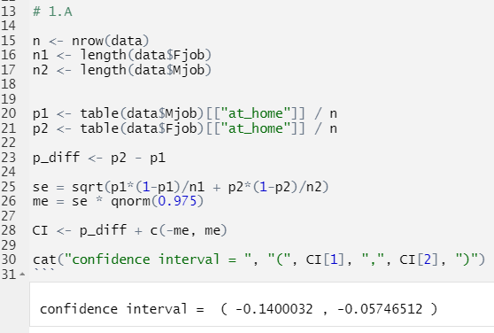

## 1.B

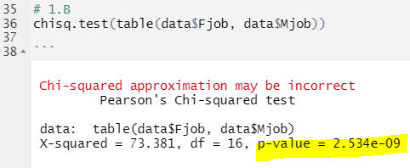

# Question 2: